**MEMORY MANAGEMENT**

**Memory Hierarchy**

* It is a way to **arrange memory** in such a way, that its access takes **less time**.

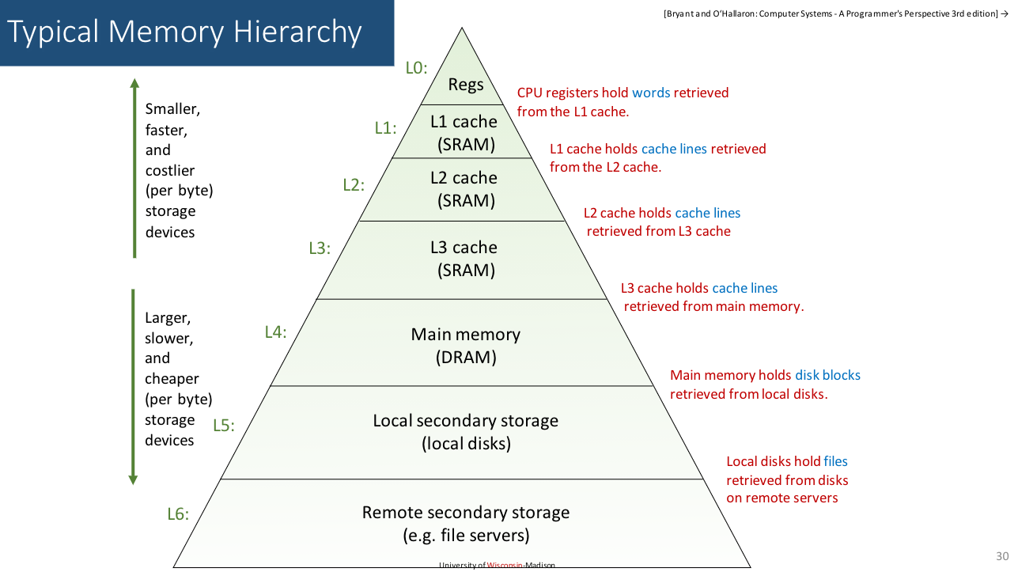

**Logical & Physical Address**

* **Logical address:** An address generated by CPU as a **reference** to its **physical address**.
* It is generally represented by **numeric digits**.

**EXAMPLE:** ***0x78C9A***, a **pointer address** in C/C++.

* **Physical address:** The **physical location** of the address.
* Physical address can be accessed **indirectly** through **logical address**.
* **Memory management unit (MMU):** A hardware device that converts **logical address** to **physical address** & vice-versa.

**Binding of Instructions & Data to Memory**

Compile time:-

* **Symbolic addresses** are **directly** converted to **absolute addresses**.
* **Symbolic address:** Variables representing an address.
* **Absolute address:** Actual memory addresses decided by assembler.
* Memory location to store data is **fixed** (**static**).

Load time:-

* **Symbolic addresses** are first converted to **relative addresses**.
* Then this **relative address** converts into **absolute address**.
* But the memory location to store data **aren’t** fixed (**static too**).

Execution time:-

* The memory locations of **data residing** in it can change during **execution time**.
* **Symbolic addresses** are converted to **absolute addresses** during **runtime** (**dynamic**).

Reloadable code:-

* Code that can be reloaded at **different memory locations**.
* Used when a **memory conflict** between a **running program** & **load time program** is faced.

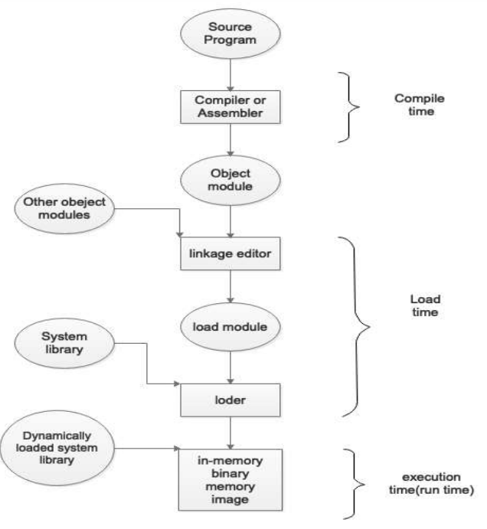

**Requirements for Memory Management**

* **Reallocation:** **Uncertainty** about location of storage of data.
* Various portions of the program must be **copied** from **secondary** to **main storage device**; during **execution**.
* But under memory pressure, the program may be **cut-pasted** rather than being **copied**.
* Memory references must be translated to **actual physical addresses**.
* **Permission** must be granted by **virtual memory space** for using it.

**Base & Limit Registers**

* **Base register:** Starting point location of a memory block.
* **Limit register:** **Length** of that memory block.

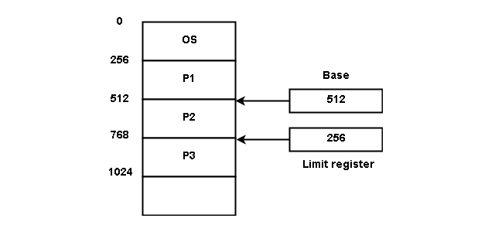

* These rules regarding **limits** & **lengths** of memory blocks are decided by the programmers while coding the OS.

**Hardware Address Protection**

* Every kind of program occupies memory space, whether made by the **clients** or by the **service provider**.
* And these programs are stored at various **main memory (RAM) locations** when running.
* Hence, the programmers make these memory locations **protected against direct access** by user.
* So that the user **can’t access** memory locations of a running program & **can’t cause trouble** to the system and applications.

Example:-

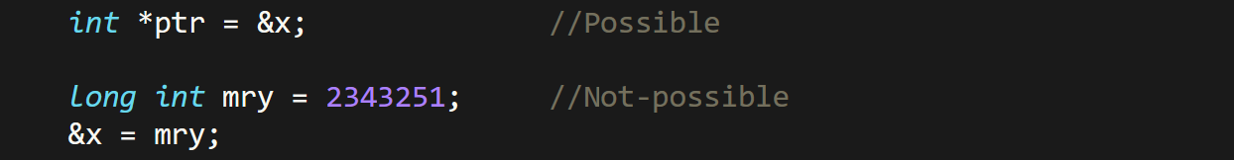

**Dynamic Relocation**

* It’s a process in which CPU assigns a **virtual address** for a **base address** of a data.
* And then the **whole block of memory** coming under that **base address** is assigned to that data as its **memory block**.
* Sometimes a data may occupy **multiple &** **consecutive memory blocks**, depending on its size.
* And when the program is **under execution**, the **data** at those memory locations are put in place of **variables** in the program.

**Static v/s Dynamic Loading**

|  |  |
| --- | --- |
| **Static** | **Dynamic** |
| **Whole program loads into the main memory at once.** | **Only required parts of the program are loaded into the main memory.** |
| **High overhead on memory.** | **Low overhead on memory.** |
| **Faster** | **Slower** |
| **Overhead during compilation.** | **Overhead during runtime.** |
| **Uses static linking.** | **Uses dynamic linking.** |
| **Abstracted data are loaded during compile time.** | **Bit by bit data are loaded during runtime.** |

**Swapping**

* Temporarily, **copy of program** is made & loaded into the **main memory** for execution.
* This **copy** is known as ***memory image*** & maintained by **ready queue**.
* **Roll in roll out:** High priority algorithms are **swapped** & lower priority algorithms are **updated** to secondary memory and **removed** from main memory.
* And the memory space where these activities take place is known as **user space**.

**Memory Management Techniques (MMT)**

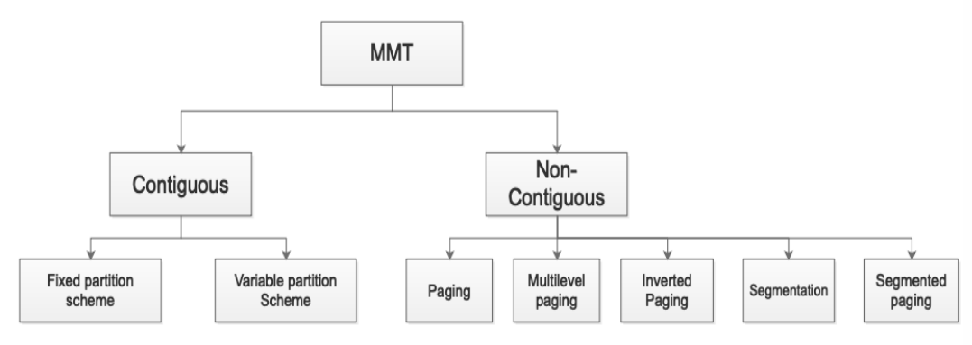

* **Memory management technique** can be called ***memory allocation*** interchangeably.
* **Memory allocation** can also be called as ***reserving memory***.

**Contiguous Memory Allocation**

* Process **requests memory** before executing.
* If sufficient contiguous space is **not** available, then process enters into **waiting queue**.

Parts of main memory:-

* **Low memory:** Stores everything related operating system.
* **High memory:** User memory space.

Ways to make memory partition:-

* Single process monitor
* Multiprogramming with fixed partition
* Multiprogramming with variable partition

**Single Process Monitor**

* Main memory is divided into **OS** & **user process** (general partition).
* The space given to both OS & user are **fixed**.
* Means **neither OS nor user** can invade each other’s memory space.
* And only one process can be loaded at a time to memory in single process monitor.
* It doesn’t support multiprogramming.

**Multiprogramming With Fixed Partition (MFT)**

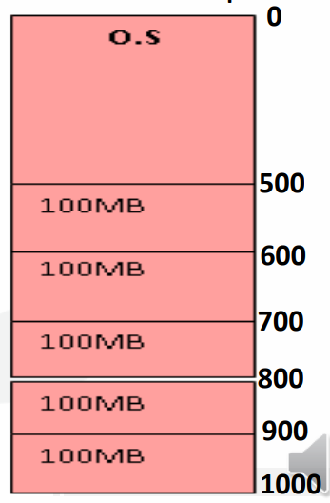

* ***Main memory*** is divided into **multiple slots** & each process is given a separate slot.
* This partition is done to **support multiprogramming**.
* The slots are divided **equally**.
* The number of partitions is **fixed**.
* Then these processes as per **their sequence** of entering the main memory, will be **contiguously arranged** in it.

Advantages:-

* Easy implementation
* Low overhead

Disadvantages:-

* Internal fragmentation
* External fragmentation
* Limitation of **process’ size**
* Limitation of **degree of multiprogramming**
* **Degree of multiprogramming:** Number of processes **active** in memory.
* **Fragmentation:** Presence of **unusable memory space** in computer.

**Multiprogramming With Variable Partition (MVT)**

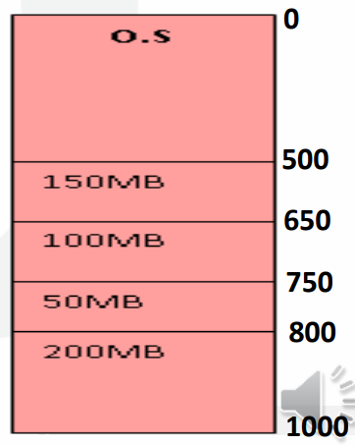

* Partitions are created **dynamically**.
* A **new partition** is created when a **new process** enters the memory.
* This overcomes shortcomings of ***fixed partition***.
* The available memory to a slot **can vary**.

Advantages:-

* No internal fragmentation.
* Proper use of memory.

Disadvantages:-

* External fragmentation.
* Difficult to implement.

**Internal Fragmentation**

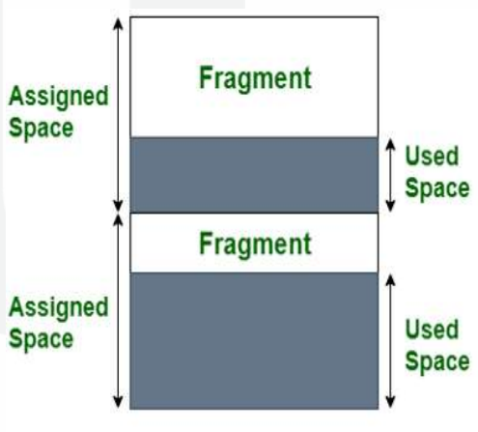

* The memory allocated to store data is **more than required**.
* This extra occupation **wastes** our memory.
* And this difference between **assigned** & **requested memory** is known as ***internal fragmentation***.
* The core reason behind ***internal fragmentation*** is **fix-sized** memory block.

**External Fragmentation**

* Unlike ***internal fragmentation***, it occurs in **dynamic** memory allocation.
* It is when using dynamic memory allocation, a small amount of memory is **allocated along & remains unused**.
* This occurs because dynamic memory allocation is **non-contiguous** & thus **leftover space** between two such dynamic processes might **not** be enough to fit another process, resulting in **wastage**.

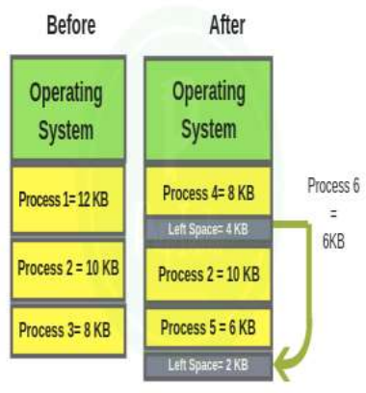

External fragmentation elimination methods:-

* Compaction
* Paging
* Segmentation

**Compaction**

* In ***compaction***, all processes in memory space are moved **upward** or **downward**.
* They are moved in such a way that the processes **don’t** start **overlapping** each other; or **invade** each other’s space.
* Then we find the **leftover space** between them **shifted downward**.
* It makes all processes **contiguous** despite having **dynamically** allocated spaces.

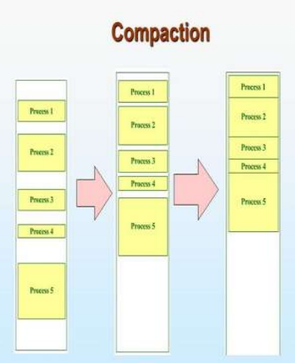

* However, it is **not advised** to used ***compaction*** technique; because it **interrupts** all the running processes in the **main memory**.

**Paging**

* In ***paging***, the processes are stored in form of **pages**.
* And **each page** corresponds to **a** ***frame*** (pages are **mapped** to frames).
* **Frame:** Group of pages.

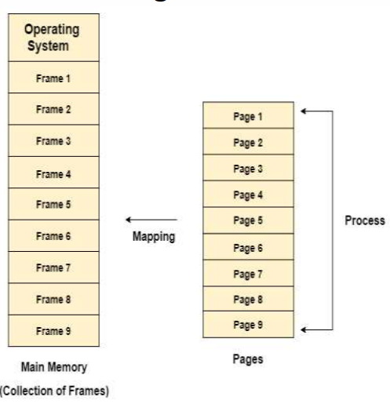

* Pages can be more easily defined as **parts of processes**.
* Whenever there are **non-contiguous** empty spaces, then pages of a **new** process can be added at **those empty spaces**.

**Memory Management Unit (MMU)**

* Logical address has 2 parts: **Page number** & **offset**.
* **Page number:** It is converted into **frame number** later on.
* **Offset:** It is the distance from one point to another in **bytes**.

**Address Spaces**

* **Physical address space:** Size of the main memory.
* **Logical address space:** Depends on size of the process.

**Word**

* **Smallest unit** of memory, varying across various OS.
* We know that **decoders** are in ratio of ***N2:N***.
* So, ***2N*** memory addresses are produced by the OS.

**Page Table**

* A **data structure** used by **virtual memory system** for storing mappings of ***physical*** & ***logical addresses***.
* CPU generates ***logical addresses*** for each process’s page.

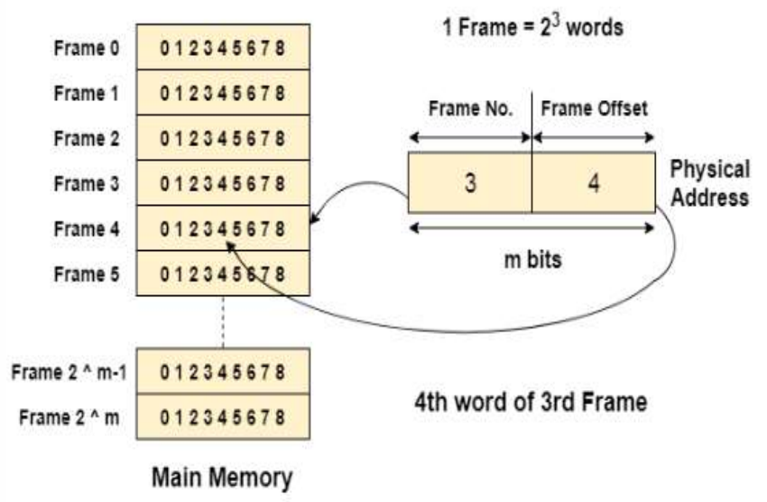

**Page Table Mapping**

* It contains mappings of ***logical address*** to ***physical address***.
* **Page table base:** A special number.

Page table structure:-

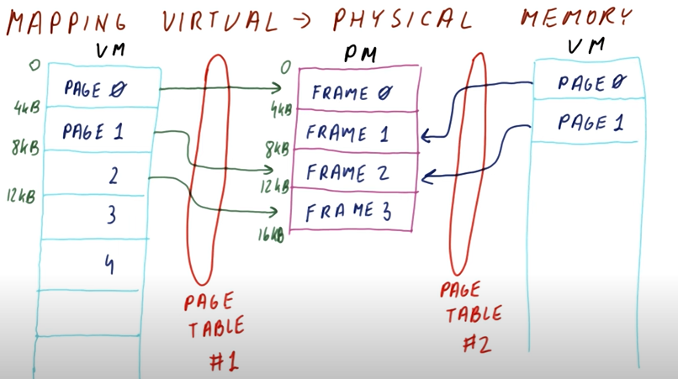

* ***Physical memory*** contains ***frames*** & ***frames*** are set of ***pages***.
* And ***pages*** are references to ***physical addresses***.
* **Virtual memory** stores ***pages*** & there can be multiple **virtual memories**.

Steps involved:-

***\*I think you know it, come on say it* ~Tyler Durden***

**Page Allocation**

* RAM divides ***physical memory*** into several ***frames*** & each ***frame*** has a fixed size.
* Individual size might be different, but they **can’t** vary.
* ***Virtual address space*** is divided among ***pages***, as ***pages*** are virtual.
* One advantage of **page allocation** is that an empty ***frame*** can be used by any process for creating & storing pages in it.
* But we also get a responsibility to **track** the number of pages & its location.

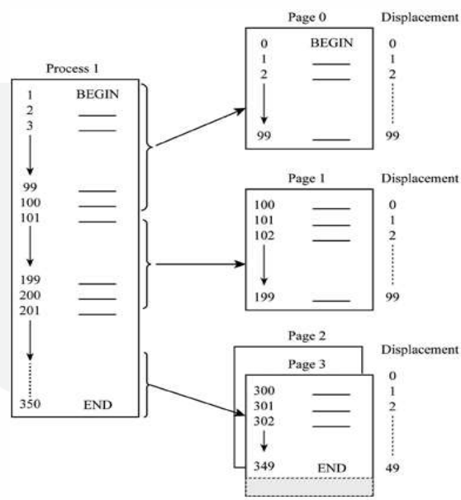

* A process is divided into various ***pages*** as shown above.
* It means that a **process** occupies a ***frame*** that containing many ***pages***.
* And a ***page*** contains many memory locations.
* Consider **process** as **soul**, ***frame*** as **body**, ***pages*** as various **body parts** & **memory** as **physical volume**.

Steps to determine location of instruction/code:-

* **Step 1:** Know the required **page number**.
* **Step 2:** Determine the **frame memory size** containing the page.
* **Step 3:** Get the **base address** of that memory block.
* **Step 4:** **Traverse forward** in the memory as per the **sequence** of page.

**Hardware Support**

* **Page table storage** methods may vary in different OSes.
* Information about **pointer** to **page table** can be found on **PCB**.

Method – 1:-

* **Page tables** are stored in different **special registers**, but it is useful only when **page table** is small.
* Thus, in todays OSes its **not** an efficient option.

Method – 2:-

* By usage of ***translation look-aside buffer*** (***TLB***).
* With this approach, we use **small** & **fast** hardware.
* It involves **key-value** pairs stored in ***TLB***.
* Previous approach takes a **long time** to access the memory.
* Whenever a ***logical address*** is generated, its ***page number*** is stored in ***TLB***.
* When a process is being accessed & its ***page number*** is found in ***TLB***, its ***frame number*** is made available to be used.
* If its ***page number*** is **not** found in ***TLB***, its ***page number*** & ***frame number*** is added to ***TLB***.

**Paging Hardware With TLB**

* If ***TLB*** is **out of space** to add more entries, some entries are **removed** using a special algorithm called ***LRU***.
* Some ***TLBs*** **wire** the entries, meaning they **can’t** be removed.
* Some ***TLBs*** also store ***address space identifier (ASID)*** of each entry.
* ***ASID*** **not** only identifies each process uniquely, but also provides address space protection to them.
* **Hit ratio:** Percentage of **number of times** a page is found in ***TLB***.
* **Effective access time:** Total time taken to search the ***TLB***.
* If a page is found, it takes certain time to **traverse** & **access** its memory.
* Else if it is **not** found, then it takes time for **traversing** **only** & moves on.
* In general, it takes **20 ns** to **traverse** one record to another.
* And **100 ns** to access its memory location.

**Merits & Demerits of Paging**

Advantages:-

* Fast memory allocation & deallocation.
* Non-contagious memory space, fitting wherever possible.
* No external fragmentation.

Disadvantages:-

* Internal fragmentation.
* Page tables occupy a lot of memory.

**Memory Protection**

* The ***frame*** allocated to a ***page*** is permanent, it **can’t** be replaced.
* **Protection bit:** A special bit used for each ***frame*** for its memory protection.
* ***Protection bit*** can also be found in ***TLB***.
* **Valid bit:** A special bit which detects **which *page*** is currently running.
* **Invalid bit:** A special bit which detects which bits are **not** running.
* However, some systems may use ***page table length register (PTLR)***.
* ***PTLR*** scans whole ***page table*** & determines its **length**, which helps in tracking the **last valid address** i.e. address of ***page*** currently in use.
* There can be multiple **valid** & **invalid** pages.

**Segmentation**

* A memory management logic.
* It says that memory is divided into various **segments**.
* These segments are occupied by running processes.
* Addresses are specified by a **segment name** & an **offset**.
* Segments are referred by **segment numbers**, **not segment names**.

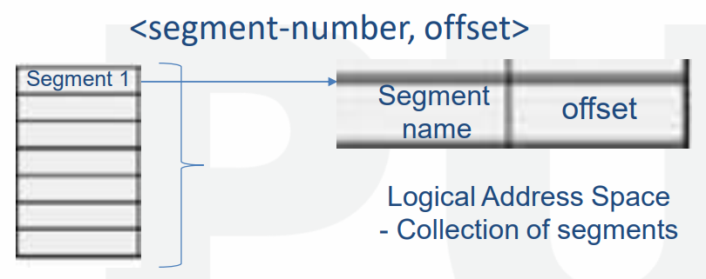

* ***Segment offset*** is referred using ***segment number***.
* **Segment offset:** Represents original location of the segment.

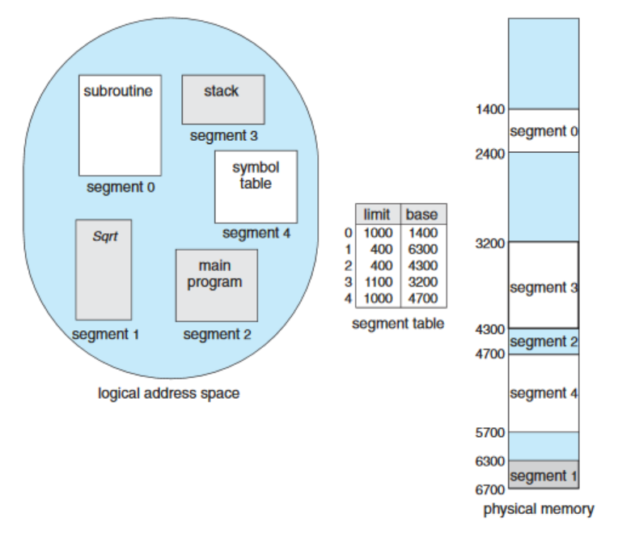

**Hardware Implementation of Segmentation**

* ***Logical address*** is **2D**, as it contains ***segment name*** & ***offset***.
* ***Physical address*** is **1D** with address only.
* We use ***segment table*** to represent these ***2D addresses*** into ***1D*** and vice-versa.
* ***Segment table*** contains **base** & **limit**.
* ***Logical address*** consists of two parts: **S** & **D**
* **S** represents **indexing of segments** in table.
* **D** is a value lying between **0 and segment limit**.
* **Segment limit:** Size of segment.

**Segmentation v/s Paging**

|  |  |
| --- | --- |
| **Segmentation** | **Paging** |
| **Program is divided into segments.** | **Program is divided into pages.** |
| **Size of segments can vary.** | **Size of pages are fixed.** |
| **Users can guess how it looks in memory.** | **Difficult to visualize it.** |
| **No internal fragmentation problem.** | **Has internal fragmentation problem.** |
| **Has external fragmentation.** | **No external fragmentation.** |
| **OS maintains list of vacant spaces.** | **No list is maintained for vacant spaces.** |

**Merits & Demerits of Segmentation**

Advantages:-

* Each segment can be operated separately.
* Data sharing among processes is more efficient.
* Uses more efficient addressing method.
* Memory areas can be shared among heap, stack, code, data etc.

Disadvantages:-

* Difficult to implement
* Paging can interfere with segmentation when recognizing available free space.

**Types of Page Table Structures**

* Hierarchical paging
* Hashed page table
* Inverted page table

**Hierarchical Paging**

* Also known as **multilevel paging**.
* Page tables are arranged in a **hierarchical** manner.
* Entries of a table are **pointers** to table below in hierarchy.
* Entries in **last *page table*** are information about ***frames***.
* **Address** of the ***page table*** at **level 1** is stored in ***PTRB***.
* **PTRB:** Page table base register.

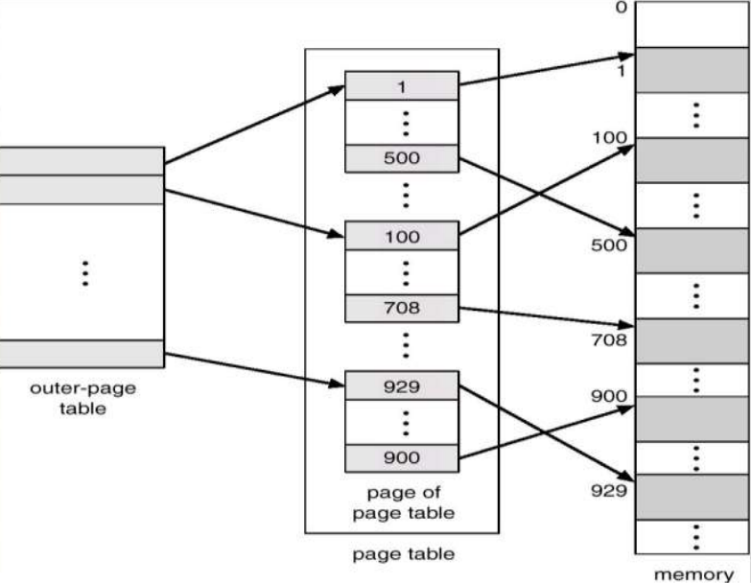

**Hashed Page Table**

* Used in **address spaces** larger than **32-bits**.
* Has a ***page table*** which contains array like **elements**.
* Each **element** contains:
  + Virtual page number
  + Value of the mapped frame
  + Pointer to next element
* So, later on when a certain ***virtual page*** is being searched, the **matching element** from ***hash page table*** is selected & its ***physical frame*** is extracted.

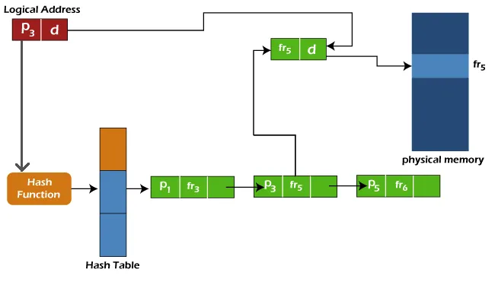

**Inverted Page Table**

* A regular ***page table*** uses **linear search** page-by-page for finding the required page.
* And that’s how the memory management system usually keeps track of all the pages.
* But in ***inverted page table***, rather than having separate **page tables**, everything is stored in **one big table**.
* So, it contributes to the **linear search** **efficiency** when a ***page*** is searched.
* It takes **more time** to search, but **reduces** the memory occupation.

Entries in table:-

* **Virtual page number:** The reference to physical page number.
* **Physical page number:** The actual physical page number.